 **Lovely Professional University**

**REPORT**

# Smart Dustbin with Dry and Wet Waste Segregation using IOT

Anubhav Singh Mohit Manhas Vishal Kumar Ayush Agarwal Anjani kumar Dr. Deepika Ghai

BCA, LPU BCA, LPU BCA, LPU BCA, LPU BCA, LPU Professor, LPU

***Abstract:*** In present scenario efficient waste management is the major objective of the country. Segregation of waste and creating awareness of different types of waste is new boom. Waste from the houses can be broadly divided into two categories dry waste and wet waste. It is recommended to have two separate dustbins in the house to keep wet waste from mixing up with its dry counterpart. Due to lack of awareness in citizens they prefer mix all the waste and disposed. It is just loss to ecosystem as well as individual health due to poisonous gas emission from waste. Bad smell spreads and may cause illness to human beings. It also leads to unhygienic environment and look of the city. In this proposed system smart dustbin will be created in which soil moisture sensor sense the moisture of waste and based on threshold value desired one will be entered as input. To achieve the overall scenario IOT technology will be used.

***Keywords:*** Internet of Things; Solid Waste Management; Ultrasonic and IR Sensors; Servo Motor; Soil Moisture Sensor; Rasberry-Pi.

## I. INTRODUCTION

In this world of Wi-Fi and 4G, the new wave of modern technology is Internet of Things commonly called as IOT. The real goal is to use every object as a part of the network, and not just embedding intelligence in smart phones and laptops. Sensor network technology play key role in IOT based devices. Most people think that accumulation of waste starts once the garbage reaches the huge dustbin vans or the dumping grounds but in actual it starts right at your house. These smart bins will lead to proper waste management. In our system, idea is suggested where we can create dustbins that will accept the waste in segregate form only. The idea is to place two dustbins of different colour at every street one for wet waste and one for dry waste. So even if it doesn’t get segregate at individual level, it can be done at street level. Both the dustbins are interfaced with micro controller base system and soil moisture sensors of certain numbers. This system is interfaced with LCD to observe the results. The data has been received, analysed and processed, which displays the status of the Garbage which one is trying to feed, if found right then will accept it otherwise not. Also transfer of waste to dump yards can be tracked and real time status of waste can be viewed on GUI of the web browser.

## II. LITERATURE REVIEW

Smart ecosystems based on IoT technology are becoming more and more popular. The main motto of IoT is to connect the hardware world to the internet. Some of the research publications that help us to do this paper are discussed here. A Line follower bin is designed to detect the obstacle using Rasberry-Pi , LCD, motors, and battery to indicate the filled Level of the dustbin and also, to communicate. This paper discussed the system that is used to indicate the filled Level and to establish

Communication through Blynk App, Wireless mesh network, Ultrasonic, IR, Proximity sensors, LCD, Servo Motor, Soil Moisture Sensor, Po Battery, etc., The clever trash can gadget may be very beneficial for tracking the trash cans and offers information about the extent of the rubbish accrued withinside the trash

cans through an IR sensor, Arduino and this gadget robotically locks while it rains, detected at through the rain sensor. The system uses a microcontroller interfaced with SPI through Ethernet to the web page. The device makes use of an ultrasonic sensor to come across the stage of the trash can.

Gas sensors are used to detect toxic or explosive gases and measure their gas concentration. If the toxicity level is well below 10 cm, or if the gas is highly toxic, a message will be sent to the metropolitan community via GSM module. Trash records also can be despatched to the internet site so that this record saved at the internet site. The records are stored with

the date and time. When the city government knows about that the trash can is full, it asks the truck driver to clean the trash can. In this way, the trash can is cleaned in a timely manner.

The paper describes an automated waste separation system using a programmable logic controller (PLC). This document reports the ambition to separate plastics, glass bottles and metal cans from stable waste. The paper s an automated waste separation system using Rasberry-Pi. The strength of smart cities are improved by Fog computing using IoT architecture.

based control system using sensors. In Waste water treatment, parameters are estimated using whale optimized Fuzzy and chaos theory and BAT algorithm. Smart voting machine has been developed using liveness detection module through finger print technology. Artificial IoT based smart bin has been designed for solid waste management. The wastage segregation has been performed in an intelligent route (IoT)using solar energy. Efficient smart bin management system has been developed using IoT [19]. In traditional methods, garbage monitoring system has been handled with some limitations. The above said methods have low data speed, high maintenance cost, low network stability, heavy manpower and needs additional special device training and more time consuming. The proposed method concentrates in solving those issues.

Nowadays, the garbage waste management is being developed using Internet of Things to detect and make the smart bin empty. In this system, IR sensors and inductive proximity sensors detect the metal debris. In this paper, waste is classified into wet and dry according to its weight**.**

## III. METHODOLOGY

The methodology for the proposed solution has been developed as shown in Fig. 1.

The idea is to use sensors not just for level indication, but also for sensing state of matter of waste being disposed. Our system suggests that used two bins one for solid waste and one for liquid waste collection. Solid waste predominantly, is any garbage refuse or rubbish that we make in our homes and other places. These include old car tires, old newspapers, broken furniture and plastics, paper, rubber, metals, leather, cloth rags, wire, glass and things etc. fall under the category of dry waste. Wet waste includes cooked and uncooked food, waste from fruits and flowers, fallen leaves, dust from sweeping and other eatable items.

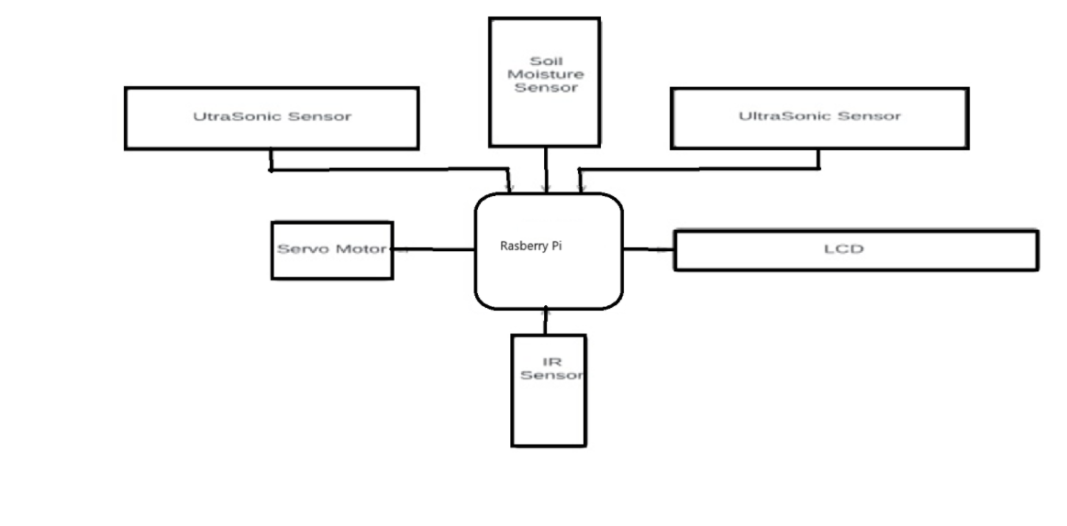

### Fig. 1 Proposed Model

Soil moisture sensors are attached to dustbins. If the dustbin size is big, then more sensors will be needed. But the necessary condition is that the number of sensors should be odd. The principle is every object will have certain amount of moisture. Sensor will calculate the moisture of every object (waste). Decide certain threshold value to differ solid waste from liquid waste. Say if threshold value is set to 10% for solid waste collection bin and more than this will be considered as liquid waste. Calculate the moisture level of all the waste input. Now that moisture content is calculated using all the soil moisture sensors.

Every sensor will have value of flag as zero and one. If the moisture content will be less than or equal to 10% then flag will give the value of one. If moisture content exceeds 10% then flag will give the value of zero. The value of all the sensors is observed. If flag value of one is more than waste will be input to solid waste bin else it will be input in liquid waste bin. The dustbin should have two levels. Top level will perform this calculation and if find right then certain slider which will dispose the waste to bottom. If the waste found to be input in wrong bin, then it will throw it out in certain bowl. From that bowl one should disposed the waste in proper bin to be accepted. Micro processor will used to receive data from sensor. processed data that data is processed and can be viewed on LCD. Though completely not achieved but yet the new start to segregation of waste can be observed. The amount of recyclable waste will surely be in more much amount as compare to current scenario. After that IR sensor will sense data once bins level gets complete. The bins will be emptied and can be tracked using WIFI and RFID technology. System Architecture.

1. **Rasberry -Pi**: The Raspberry Pi is a compact, affordable computer popular for DIY

electronics and programming projects. Key

features:

**Models:** Various options like Pi 4, Pi 3, and

Pi Zero with differing specs.

**OS**: Runs Raspberry Pi OS, with

alternatives

like Ubuntu and Windows IoT.

**Programming**: Supports languages like

Python, C/C++, and Java

. **GPIO Pins**: Allows connection to hardware

like sensors and LEDs.

**Accessories**: Camera modules, HATs (add-

ons), and displays for enhanced functionality.

1. **Ultrasonic sensor**: The usage of the ultrasonic sensor is to measure the distance with an accurate and stable measurements. The sensor can measure distances from 2 cm to 400 cm, or even from one inch to thirteen feet. This sensor sends ultrasonic waves into the air at a frequency of 40 K Hz, and when

an object gets in the way, it bounces off the sensor. There are 4 pins. Two pins, VCC and GND connected to the Microprocessor 5V and

GND, and the rest of two pins are the Trigger and Echo pins connected to any of the Rasberry-Pi digital pins. Trigger pins send signals and echo pins are used to receive signals. The trigger pin should be high for approximately 10 microseconds to generate an ultrasonic signal. This sends an eight-cycle sound pulse at the speed of sound, hits the object and receives at the echo pin.

1. **Servo motor**: Servo motors help lock the lid of the trash can. Arduino is programmed to automatically close the lid after it detects a full trash can. This is done using this servo motor. There are three wires to connect, brown, red and orange. Brown is the ground wire connected to the ESP32 ground. Red is the power normally used at + 5V. Orange is the PWM signal to drive the motor. The operating voltage is typically + 5V and the torque is 2.5 kg per cm. This means that the motor can pull a 2.5kg weight when suspended at a distance of 1cm. The operating speed of the servo motor is 0.1seconds per 60 0°. The angle of rotation
2. **Proteus Software and Blynk App:**

**Proteus Software**: Proteus is a simulation software suite for electronic circuit design and testing. It’s popular for designing and testing circuits virtually before implementing them on hardware. It supports microcontrollers like Arduino, Raspberry Pi, and others, allowing users to test code and hardware interactions through realistic simulations, making it ideal for prototyping projects.

**.Blynk App**: Blynk is a platform with iOS and Android apps that can control Arduino, Raspberry Pi, and other microcontrollers over the Internet. It provides a virtual dashboard where you can create a visual interface for your project by dragging and dropping widgets, enabling remote control and monitoring.

1. **IR Sensor:** The IR sensor or infrared sensor is one kind of electronic component, used to detect specific characteristics in its surroundings through emitting or detecting IR radiation. These sensors can also be used to detect or measure the heat of a target and its motion. In many electronic devices, the IR sensor circuit is a very essential module. This kind of sensor is similar to human’s visionary senses to detect obstacles.

**6. Soil Moisture Sensor**:The soil moisture sensor is used to measure volumetric water content of soil. The soil moisture sensor uses capacitance to measure the water content of the soil. This moisture sensor will be used to measure the moisture content of waste. Range: 0 to 45% volumetric water content in soil (capable of 0 to 100% VWC with alternate calibration). Accuracy: ±4% typical. Typical Resolution: 0.1%. Power: 3mA @ 5VDC. Operating temperature: –40°C to +60°C. Dimensions 8.9×1.8 cm×0.7 cm.

## IV. ALGORITHM AND FLOWCHART OF PROPOSED MODEL

**ALGORITHM:**

Step 1: Start the experiment by taking two dustbins with sensors and other apparatus.

Step 2: Dispose the mix waste in bin.

Step 3: Calculate the moisture content.

Step 4: According to certain threshold if moisture content comes out to be greater than threshold in that case opens the liquid waste bin.

Step 5: If moisture content comes out to be less than dispose that waste out and store it in solid bin.

Step 6: The threshold value can be decided by iterative

process. In our case we repeat the process and it is set as

10%.

Test cases and Results:

|  |  |
| --- | --- |
| Dustbin moisture content | 0-10% (input in solid waste bin) |
| Dustbin moisture content | 10% (input in solid waste  bin) 3) |
| Dustbin moisture content | 1) more than 5% (input in liquid waste bin) |

Advantages of Proposed System

* Real time information on the state of the dustbin.
* Deployment of dustbin based on the actual needs.
* Cost Reduction and resource optimization.
* Improves Environment quality

-Fewer smells

-Cleaner cities

* Intelligent management of the services in the city.
* Effective usage of dustbins.

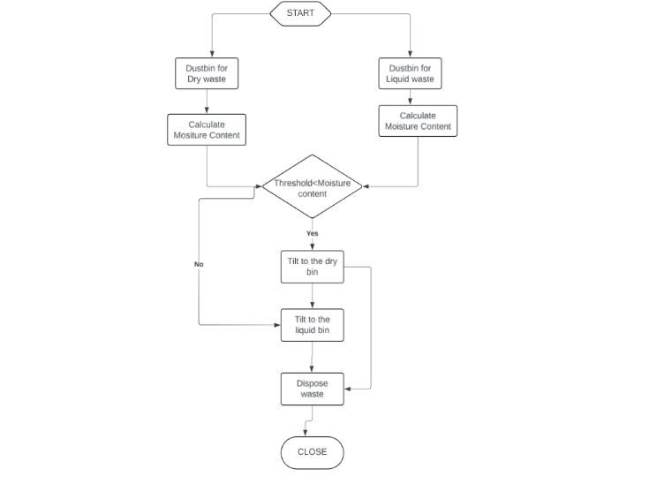

### Fig. 2 Flow Chart of Proposed Model

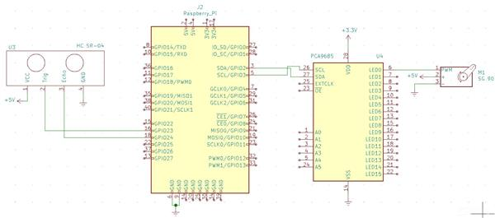

**Fig. 3 Circuit Diagram**

## RESULT AND DISCUSSION

Here we are using a one variable voltage source & we set -250V as a threshold value. By varying voltage below threshold value we got output on virtual terminal that is dustbin is not full. In proteus we connect this variable voltage source to the analog pin of ultrasonic sensor, connect trigger & echo to Arduino and potentiometer is using as moisture sensor and connecting to A0 pin of Arduino. Now upload the Arduino hex file ,after uploading the hex file, hit RUN button then virtual terminal will display distance measurement i.e. dustbin is either full or empty. Following pictures show the mobile app status and real time dustbin for 50% full dry & 100% full wet dustbin as well as database also.

### Future Works

The data collection and preprocessing can be done by Raspberry Pi, GPS and cloud infrastructure. Regular waste generation can be monitored. It would be better to put more smart containers and garbage disposal authorities in the areas where people generate more waste compared to others. In the future, it would be better to motivate people to dispose of waste properly by means of providing bonus points or rewards. The system is easily scalable to multiple number of containers. All garbage bins in the city can be connected by fully automated garbage collection system. Additional controls like automatic trash cleaning and closing the trash when it rains can be implemented in the future.

## V. CONCLUSION

This scenario will help the waste managers to recycle the waste in more appropriate way. To make it even better the power supply can be used using solar panels. This system can be implemented in waste bins which are placed in colony as well as huge places where dump yard are present, main motive is waste should be segregated. In one research it has been found that if waste of India will be recycled properly then it can be capable of giving country money in millions instead of investing money. With this the dream of developed India can be seen actually.

## REFERENCES

[1] Helen, R., Karthika, P., Selvakumar, R., & Thenmozhi, T. (2022, January). Smart bin and intelligent waste segregator using IoT. In *2022 4th International Conference on Smart Systems and Inventive Technology (ICSSIT)* (pp.

125-131). IEEE.

.

1. Mahajan, K., & Chitode, J. S. (2014). Waste bin monitoring system using integrated technologies. *International Journal of Innovative Research in Science, Engineering and Technology*, *3*(7).

1. Bhattacharya, D., & Reshmi, W. (2013, December). Analysis and design of an embedded environment informer for waste disposal cleaning. In *2013 International Conference on Green Computing, Communication and Conservation of Energy (ICGCE)* (pp. 419-422). IEEE.

1. Navghane, S. S., Killedar, M. S., & Rohokale, V. M. (2016). IoT based smart garbage and waste collection bin. *International Journal of Advanced Research in Electronics and Communication Engineering*

*(IJARECE)*, *5*(5), 1576-1578.

1. Anjanappa, C., Parameshwara, S., Vishwanath, M. K., Shrimali, M., & Ashwini, C. (2022). AI and IoT based garbage classification for the smart city using ESP32 cam. *International Journal of Health Sciences*, (III), 4575-

4585.

1. Arthur, M. P., Shoba, S., & Pandey, A. (2024). A survey of smart dustbin systems using the IoT and deep learning. *Artificial Intelligence Review*, *57*(3), 56.

[7]

<https://youtu.be/mHaeDoFOVX0?si=Go8h7e4Na08Ezz1R>Automatic Dustbin

[8]

<https://youtu.be/QDRX421WGkk?si=_EWNvLVqtHXI1wrg>Smart Dustbin

1. Udeani, H. U., Chiagunye, T. T., Okey, O. D., & Eze, C. (2022). Design And Construction of a Smart Dustbin System with Internet of Things (IoT) Notification. *FUNAI J. Sci. Technol.*, *5*(1).

1. Venu, D. N. (2023). IoT based Smart Intelligent System for Automation of Waste Management. *European Chemical Bulletin*, *12*(9), 308-322.

1. G. N. Keshava Murthy, A. S, A. K N, Y. R and J. T S,

"Automated Smart Dustbin Using ESP32," *2023*

*International Conference on Recent Advances in Science and Engineering Technology (ICRASET)*, B G NAGARA, India, 2023, pp. 1-5, doi: 10.1109/ICRASET59632.2023.10420276.

1. Singh, A., & Gupta, D. (2019). Smart Waste Management System Using IoT. International Journal of Scientific Research in Computer Science, Engineering and Information Technology (IJSRCSEIT), 4(5), 153-158.

1. Rashmi, A. A., Kulkarni, S. B., & Sushma, D. M. (2019). Smart Waste Management System using IoT. International Journal of Computer Sciences and Engineering, 7(2), 200-205.

1. Sharma, P., & Babu, S. (2018). Smart Garbage Monitoring System Using IoT. International Journal of Engineering and Technology (IJET), 7(4.28), 149-154.

1. Navghane, S. S., Killedar, M. S., & Rohokale, V. M. (2016). IoT based smart garbage and waste collection bin. *International Journal of Advanced Research in Electronics and Communication Engineering*

*(IJARECE)*, *5*(5), 1576-1578.

1. Dugdhe, S., Shelar, P., Jire, S., & Apte, A. (2016, January). Efficient waste collection system. In *2016 international conference on internet of things and applications (IOTA)* (pp. 143-147). IEEE.

1. Simon, B., Amor, M. B., & Földényi, R. (2016). Life cycle impact assessment of beverage packaging systems: focus on the collection of post-consumer bottles. *Journal of Cleaner Production*, *112*, 238-248.

1. Demirbas, A. (2011). Waste management, waste resource facilities and waste conversion processes. *Energy Conversion and Management*, *52*(2), 1280-1287.
2. Dubey, S., Singh, P., Yadav, P., & Singh, K. K. (2020). Household waste management system using IoT and machine learning. *Procedia Computer Science*, *167*, 1950-1959.

1. Shirke, S. I., Ithape, S., Lungase, S., & Mohare, M. (2019). Automation of smart waste management using IoT. *International Research Journal of Engineering and Technology*, *6*(6), 414-419.

1. Naresh, R., Meenakshi, M., & Niranjana, G. (2020). Efficient study of smart garbage collection for ecofriendly environment. *Journal of Green Engineering*, *10*(1), 1-10.

1. Joshi, S., Singh, U. K., & Yadav, S. (2019). Smart dustbin using GPS tracking. *International Research Journal of Engineering and Technology (IRJET)*, *6*(06).

1. Velmurugan, T., Prakasam, P., Mohammed, V. N., & Saravan, K. (2019). Smart garbage monitoring and navigation system using IoT. *International Journal of Innovative Technology and Exploring Engineering*, *8*(11), 3992-3996.

[24]

1. Kumar, A., & Jain, A. K. (2021). Mutual authentication protocol for low cost passive tag in RFID system. *International Journal of Information*

*Technology*, *13*(3), 1209-1215.

1. Gull, S., Bajwa, I. S., Anwar, W., & Rashid, R. (2021). Smart eNose food waste management system. *Journal of*

*Sensors*, *2021*, 1-13